Course: High Performance Computing Lab

Practical No 1

PRN: 21510069
Name: Harsh Bankat Karwa
Batch: B3

Title: Introduction to OpenMP

Problem Statement 1 – Demonstrate Installation and Running of OpenMP code in C
Recommended Linux based System:
Following steps are for windows:
OpenMP – Open Multi-Processing is an API that supports multi-platform shared-memory multiprocessing programming in C, C++ and Fortran on multiple OS. OpenMP uses a portable, scalable model that gives programmers a simple and flexible interface for developing parallel applications for platforms ranging from the standard desktop computer to the supercomputer.

To set up OpenMP,
We need to first install C, C++ compiler if not already done. This is possible through the MinGW Installer.
Reference: Article on GCC and G++ installer (Link)
Note: Also install `mingw32-pthreads-w32` package.

Then, to run a program in OpenMP, we have to pass a flag `-fopenmp`.
Example:
To run a basic Hello World,
#include <stdio.h>
#include <omp.h>

int main(void)
{
#pragma omp parallel
printf("Hello, world.\n");
return 0;
}

gcc -fopenmp test.c -o hello
.\hello.exe
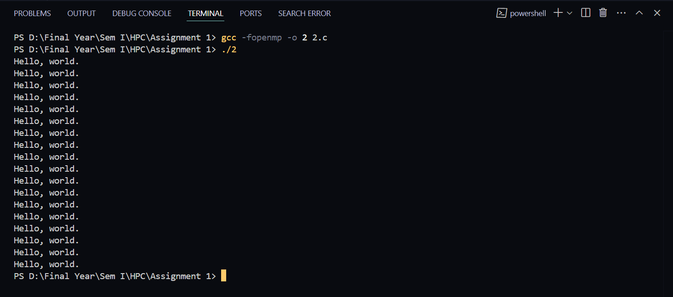

Problem Statement 2 – Print ‘Hello, World’ in Sequential and Parallel in OpenMP
We first ask the user for number of threads – OpenMP allows to set the threads at runtime. Then, we print the Hello, World in sequential – number of times of threads count and then run the code in parallel in each thread.

Code snapshot:

#include <stdio.h>
#include <omp.h>

int main(void)
{
int num_threads = 0;

printf("Enter the number of threads: ");
scanf("%d", &num_threads);
double start_time = omp_get_wtime();
printf("\nSequential printing:\n");
for (int i = 0; i < num_threads; i++)
{
printf("Hello, World\n");
}
double end_time = omp_get_wtime();

printf("TIME FOR SEQUENTIAL PRINTING: %f\n", end_time - start_time);

omp_set_num_threads(num_threads);
printf("\nParallel printing:\n");
start_time = omp_get_wtime();
#pragma omp parallel
{
printf("Hello, World from thread %d\n", omp_get_thread_num());
}

end_time = omp_get_wtime();

printf("TIME FOR Parallel PRINTING: %f\n", end_time - start_time);

return 0;
}

Output snapshot:
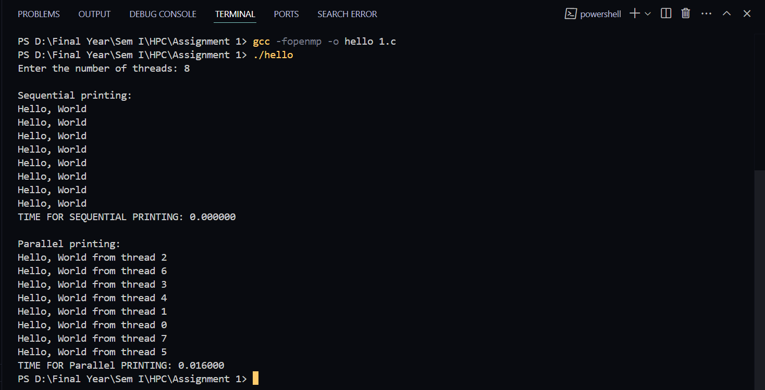
Analysis:

GitHub Link: make a public repository upload code of an assignment and paste its link here.

Problem statement 3: Calculate theoretical FLOPS of your system on which you are running the above codes.
cat /proc/cpuinfo
lscpu | grep “Mhz”

No of Flops: No of Core * ClockSpeed * IPC * 10**9
No of Core = 18
Clock Speed = 1.2GHz
IPC = 16
ANS:= 345.6 GFLOPS

